Market Information
The market information on seeds of forestry species, industrial woods and timber species of both native and imported ones are provided based on the survey conducted in different saw mills, timber importing agencies, procurement agents, sales and marketing personnel. The information is updated on a regular basis. The price within a species varies according to its dimensions. The quality of wood is determined based on texture, weight, color, durability, resistance to moisture, flexibility, material strength, fiber and surface finish, etc. The list of major timber species imported in Tamil Nadu and Kerala, market information on seeds of forestry species, market information on wood and Trade name and local names of timber species found in South India are provided in this section.

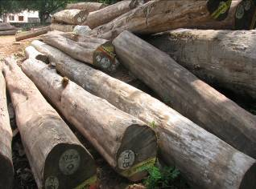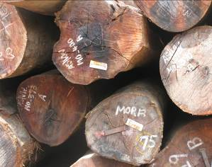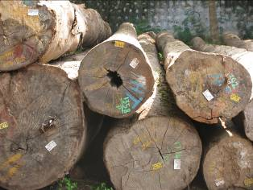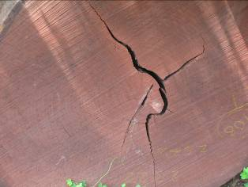

List of Major Timber Species Imported in Tamil Nadu and Kerala
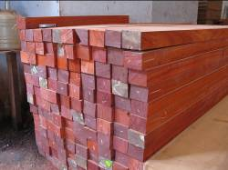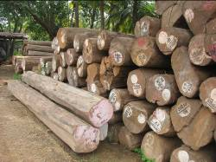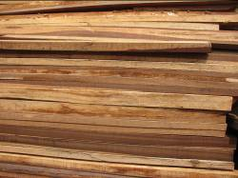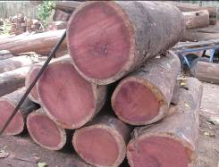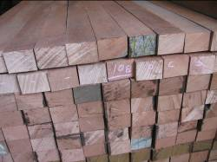
S.No | Common Name | Botanical Name | Origin | Class
1 | Meranti (Red, White, Yellow) | Shorea leprosula | Malaysia | LHW
2 | Mersawa | Anisoptera spp. | Malaysia | LHW
3 | Selangan Batu/ Balau | Instia palembanica | Malaysia, PNG | HHW
4 | Merbau | Intsia bijuga | Malaysia, PNG | HHW
5 | Penyau | Upuna borneensis | Malaysia | HHW
6 | Resak | Vatica spp. | Malaysia | HHW
7 | Kapur | Dryobalanops aromatica | Malaysia | MHW
8 | New Zealand Pine | Pinus radiata | New Zealand | LHW
9 | Kempas | Koompassia malaccensis | Malaysia | MHW
10 | Keruing / Gurjan | Dipterocarpus spp. | Mlysa, Idansa, Myanmer | MHW
11 | Rengas | Gluta spp. | Malaysia | MHW
12 | Purple Heart | Peltogyne spp. | Brazil, Guyana,  S. American forest | MHW
13 | Green Heart | Chlorocardium rodiei | Brazil, Guyana,  S. American forest | MHW
14 | Wamara | Swartzia Leiocalycina | Brazil, Guyana,  S. American forest | MHW
15 | Kabukali | Groupia glabra | Brazil, Guyana,  S. American forest | MHW
16 | Shibidan | Aspidosperma album | Brazil, Guyana,  S. American forest | MHW
17 | Tatabu | Diplotropis purpurea | Brazil, Guyana,  S. American forest | MHW
18 | Mora | Mora excelsa | Brazil, Guyana,  S. American forest | MHW
19 | Pinkado | Xylia dolabriformis | Myanmer, India | MHW
20 | Teak | Tectona grandis | Myanmar, Ghana, Nigeria, Ivory Coast, Cameroon, etc. | MHW
Market rate for Seeds of Forestry species
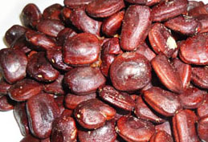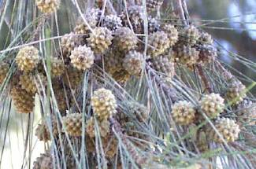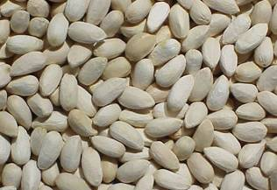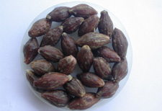
Tamil Nadu Forest Department Seed Centre
S. No | Tree Species | Common Name | Rate per Kg
1 | Tectona grandis | Teak | 39.60
2 | Melia dubia | Malai vembu | 50.00
3 | Pterocarpus marsupium | Vengai | 38.25
4 | Dalbergia latifolia | Rose wood | 100.50
5 | Gmelina arborea | Kumil | 45.20
6 | Ailanthus excelsa | Perumaram | 68.08
7 | Albizia lebbeck | Vagai | 45.20
8 | Azadirachta indica | Neem | 22.67
9 | Bambusa bambos  Dendrocalamus strcitus | Bamboo | 85.50
10 | Cassia fistula | Sarakondrai | 42.50
11 | Pongamia pinnata | Poongam | 33.00
12 | Emblica officinalis | Amla | 61.24
13 | Holoptelea integrifolia | Indian elm | 108.00
14 | Pterocarpus santalinus | Red sanders | 44.75
15 | Santalum album | Sandal | 66.45
16 | Sapindus emarginatus | Soapnut | 34.75
17 | Tamarindus indica | Tamarind | 20.94
18 | Terminalia arjuna | Neer Marudhu | 20.94
19 | Terminalia bellerica | Myrobalan | 37.50
20 | Grevillea robusta | Silver oak | 1500.84
21 | Swietenia mahogany | Mahogany | 36.00

Market Information on Woods
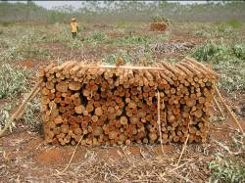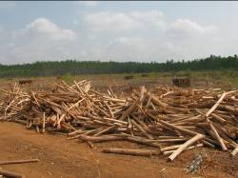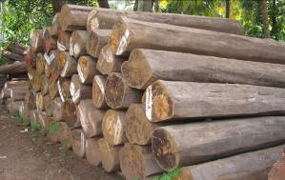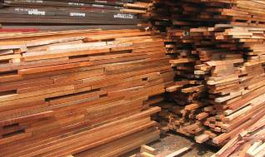
S.No | Name of the Species | Unit | Market Rate
I | Industrial Wood |  | Round Wood | Sawn Timber
1 | Casuarina | MT | 2,150.00
3 | Eucalyptus | MT | 1,900.00
4 | Ailanthus | MT | 3,200.00-3,500.00
5 | Bamboo | MT | 1,800.00-3,000.00
II | Poles
 | Casuarina
 | 12'-14' | MT | 1,800.00
 | 16'-18' | MT | 2,200.00
 | 18'-22' | MT | 2,600.00
 | Above 22' | MT | 2,900.00
III | Timber species
 | Native
1 | Teak Kerala | CFT | 2400 - 4000
2 | Teak Farmland | CFT |  | 1800 - 2400
3 | Neem (Azhadirachta indica) | CFT |  | 600-700
4 | Kumil (Gmelina arborea) | CFT |  | 700 – 1350
5 | Vagai (Albizzia lebbeck) | CFT |  | 650 – 700
6 | Malai Vembu (Melia dubia) | CFT
7 | Karuvel (Acacia nilotica) | CFT |  | 400- 500
8 | Mangium (Acacia mangium) | CFT |  | 900 – 950
 | Imported Timber
1 | Myanmar Teak | CFT | 1,200-3,000 | 2,500-3,700
2 | Ghana Teak | CFT | 700-1,500 | 1,300-2,000
3 | Nigerian Teak | CFT | 7,50-1,500 | 1,900-2,100
4 | Ivory coast Teak | CFT | 700-1,500 | 1,300-2,000
5 | Costa Rica Teak | CFT | 7,00-1,500 | 1,300-2,000
6 | African Padauk | CFT | 1,200-1,600 | 1300-2200
8 | Gurjan | CFT | 700-750 | 850-900
9 | Vengai | CFT | 1-200-1,400 | 1,700-1,800
10 | Purple heart | CFT | 900-1,100 | 1,400-1,500
11 | Kussiya | CFT | 1,000-1,500
12 | Mora | CFT | 650-700 | 850-900
13 | Green Heart | CFT | 700 | 850-900
14 | Malaysian Hard Woods | CFT | 550-700 | 750
15 | Salenganpattu/Sal/Kongu | CFT | 1,200 | 1,400-1,500
16 | New Zealand Pine | CFT | 250-400

Trade Name and Local Names of Timber Species Prevalent in South India particularly in Tamil Nadu and Kerala
Sl.No | Botanical Name | Trade Name | Local Name
 | Acacia nilotica | Ba-bul | Kuruvelam (Mal.), Karijiali (Kan), Karuvel (Tam.), Nallatumma (Tel.)
 | Acacia catechu | Khair | Karangal (Tam.), Sandra (Tel.)
 | Acacia sundra | Lal-khair | -
 | Acrocarpus fraxinifolius | Mundani | Malaveppu, Karunyan (Mal), Belanji (Kan.), Malmkonnai (Tam)
 | Adina cordifolia | Haldu | Bimpu (Mal.), Yettaga (Kan), kadambari, Manjakadambai ( Tam), Bandari ( Tel.)
 | Albizzia odoratissima | Kokko | Vaka (Mal), Bage (Kan), Vagai (Tam), Dirisinam ( Tel)
 | Albizzia lebbeck | Kala-siris | Vellayaka (Mal), Salvagai (Kan), Vagai (Tam), Tell Chinduga (Tel)
 | Albizzia procera | Safed-siris | Vellayaka (Mal), Salvagai (Kan), Velvagai (Tam), Tell Chinduga (Tel)
 | Anogeissus latifolia | Axlewood | Vellanava (Mal), Bejjal, Dinduga (Kan), Vellaragai (Tam), Chirumanu (Tel)
 | Aphanamixis polystachya | Pitraj | Karagil (Mal), Mullumuttage (Mal), Vekkali Vellakongu (Tam)
 | Artocarpus heterophyllus Amoora rohituka | Kathal | Pilavu (Mal), Alasua, Halssu (Kan), Pila (Tam), Panasa (Tel)
 | Artocarpus hirsuta | Aini | Ainipilavu (Mal), Hebbalasu (Kan), Ainipila, Anjili (Tam)
 | Artocarpus lakoocha | Lakoocha | Vate (Kan)
 | Ailanthus excelsa | Maharukh | Peenari, Perumaram, Pongiliyam (Mal), Ailanthud Malabarica DC Mattipal, Pimaram (Tam), Peddamanu (Tel), Halmaddi, Maddidhupa (Kan)
 | Alstonia scholaris | Chatian | Ezhilampala, Kukampala (Mal), Ealaipalai, Mukkampelei, Palegaruda (Tam)
 | Anthocephalus cadamba | Kadam | Attuthekku, Kadambam (Mal), Kola aiyila, Vellakadam (Tam)
 | Antiaris toxicaria | Upas | Areianjili (Mal), Maravai, Peymaram (Tam)
 | Bischofia javanica | Uriam | Cholvenga (Mal), Cholavengai, Malachadayan (Tam)
 | Bridelia retusa | Kasi | Mulluvenga (Mal), Gije Komangi (Kan) Mulvengai (Tam), Koramanu (Tel)
 | Calophyllum inophyllum | Poon | Punna (Mal), Goja, Salhonne, Surahonne (Kan), Kattupunnai (Tam)
 | Casuarina equisetifolia  Casuarina junghuniana | Casurina | Chulamaram (Mal), Kesarike (Kan), Savukku (Tam), Chavuku, Saravu (Tel)
 | Cedrela toona | Toon | Churannagil (Mal), Gandhagarige (Kan) Malavembu (Tam), Galimanu (Tel)
 | Chloroxylon swietenia | Satinwood | Murugalu (Kan), Porosi (Tam), Bilga, Billa (Tel)
 | Chukrasia tabularis | Chickrassy | Malapeddy (Mal), Urulu (Kan), Madagirivembu (Tam)
 | Cullenia excelsa | Karani | Mulluchakka (Mal), Ainipila, Vedipila (Tam)
 | Canarium strictum | Whitedhup | Kunthirika-payin (Mal), Karapu, Karum, Karunkungiliamn (Tam)
 | Canthium coromandelicum | Balasu | Nannul (Mal), Karemulla (Kan), Navuga (Tam), Nallabalusu (Tel)
 | Cassia marginata | Vakai | Karum Konnai (Tam)
 | Dysoxylum malabaricum | White ceder | Vellagil (Mal & Tam)
 | Dalbergia latifolia | Rosewood | Veeti (Mal), Biti (Kan), Itti (Tam), Jittegi (Tel)
 | Diospyros melanoxylon | Ebony | Tupra (Kan), Thumbi (Tam), Tuki, Tumiki (Tel)
 | Dipterocarpus spp. | Gurjan | Kalpayaini, Kalpine (Mal), Yennemara
 | Eucalyptus spp. | Eucalypts | Karpooramaram (Tam)
 | Elaeocarpus tuberculatus | Rudrak | Kodavasi (Mal), Rudrakashan (Ten), Kadambola (Kan)
 | Evodia lunu-ankenda | Kambli | Kattu Chempakkam (Tam)
 | Emblica officinalis | Amla | Nelli (Tam & Kan), Usiri (Tel)
 | Fagara budrunga | Mullilam | Muttilam (Tam), Rhetse (Tel)
 | Gluta travancorica | Gluta | Chankurunchi (Mal), Devadari (Kan), Senkurunji (Yam)
 | Gmelina arborea | Gamari | Kumilu (Mal), Kumulu Shivane (Kan), Kumil (Tam), Gummadi (Tel)
 | Grewia tiliaefolia | Dhaman | Chadachi (Mal), Thadasalu (Kan), Thadachi (Tam), Peddajana (Tel)
 | Garuga pinnata | Garuga | Annakara (Mal), Gooda, Halabolagi (Kan), Karuvembu (Tam)
 | Grevillea robusta | Silveroak | -
 | Gardenia latifolia | Gardenia | Kambil (Tam)
 | Gyrocarpus jacquini | Tanaku | Tanaku (Tel)
 | Hardwickia binata | Anjan | Acha (Mal & Tam), Karacha, Karachi (Kan), Yepi (Tel)
 | Hopea parviflora | Hopea | Irumbagam (Mal), Bogimar (Kan), Vellaikongu (Tam)
 | Holoptelea integrifolia | Kanju | Aval (Mal), Thapsy (Kan)  Ayily (Tam)
 | Hymenodictyon excelsum | Kuthan | Vellakandamba (Mal), Doddathoppe (Kan), Paranjoti, Sagapur (Tam)
 | Kingiodendron pinnatum Hirdwickia pinnata | Pinney | Chukanna – Payini (Mal), Yennamare (Kan), Kolavu (Tam)
 | Knema attenuata | Jathikai | Chennelli Chorapanu (mal)
 | Kydia calycina | Pula | Velukku (Mal), Bendi Vattakannu, Vendai (Tam)
 | Lagerstroemia lanceolata | Benteak | Venteak (Mal), Bendeku nandi (Kan) Bethekku, Venthekku (Tam)
 | Lagerstromia speciosa | Jarul | Nirmaruthu (Mal), Poormaruthu, Pamarudu (Tam)
 | Lannea coromandelica | Jingan | Annakara, Uthi (Mal), Geru (Kan), Kalasan, Odiyanram (Tam), Guimini (Tel)
 | Lophopetalum wightianum | Banati | Balpale (Kan), Karuka, Venkatavu (Mal), Vengottai (Tam)
 | Madhuca latifolia | Mahua | Sannaippe (Kan), Nattuilupai (Tam) Ippa (Tel)
 | Mangifera indica | Mango | Sannaippe (kan, Mamaram (Tam), Mamidi Tel
 | Manilkara littoralis | Bullet wood | Elengi (Mel), Bakula Mugali (Kan) Nanupala (Tam), Pala (Tel)
 | Mesua ferrea | Mesua | Churuli (Mal), Nagasampigi (Kan), Nangal Nangu (Tam), Nagkesarai (Tel)
 | Michelia champaca | Champ | Sampige (Kan), Chabegam, Chempakam, Shambagam (Tam), Champakam (Tel)
 | Mitragyana parvifolia | Kaim | Kadamba, Vimbusirakadambu (Mal), Nedunarai, Nirkadambai (Tam)
 | Machilus macrantha | Machilus | Uravu (Mal), Gulamavo, Fulmao (Kan),  Kilamavu, Kolarmawu (Tam)
 | Melia dubia | Malabar Neem | Kattuveppu (Mal), Mallai Vembu (Tam)
 | Palaquium ellipticum | Pali | Pali (Mal), Hadasale (kan), Palvadinjan (Tam)
 | Poeciloneuron indicum | Ballagi | Vayal (Mal), Bailige, Balagi (Kan), Putangali (Tam)
 | Pterocarpus marsupium | Bijasal | Venga (Mal), Honne (Kan),  Vengai (Tam), Yegi (Tel)
 | Pterocarpus santalinus | Red Sanders | Rakthchandanam (Mal & Kan), Chemmaram (Tam), Yerrasandanam (Tel)
 | Pterygota alata | Narikel | Anathondi, Pothondi (Mal) Anaithondi (Tam)
 | Salmalia malabarica | Semul | Illavu, Poola (Mal), Illavam (Tam) Buruga (Tel)
 | Sterculia villosa | Udal | Maruthon (Mal), Vakkainar (Kan)
 | Strychnos potatorum | Chilla | Tettancottai (Tam), Indupa (Tel)
 | Swietenia mahoganii | Mahogany | -
 | Schleichera oleosa | Kusum | Puvam (Mal & Tam), Sagada (kan), Pulusari (Tel)
 | Stereospermum tetragonum | Padri | Padiri (Mal & Tam), Kaladri, Pathiri (Kan), Likirasi (Tel)
 | Strychnos nuxvomica | Kuchala | Kanjiram (Mal), Kasan, Kasarika (Kan) Yetty (Tam), Mushti (Tel)
 | Syzygium cumini | Jamum | Naval (Mal & Tam), Nerlu, Nerula (Kan), Neredu (Tel)
 | Samedera indica | Kairmgotta | Nanuchundan, Toruvattu (Tam)
 | Santalum album | Sandalwood | Chandanam (Mal & Tam)
 | Tamarindus indica | Tamarind | Puli (Tam), Hunse (Kan), Chintha (Tel)
 | Tectona grandis | Teak | Theku (mal & Tam), Saguvain, Thega, Thekinamra (Kan), Teku (Tel)
 | Terminalia arjuna | Arjun | Veillilava (Mal), Pilinaddi, Thoramatty (Kan), Vellamaruthu (Tam)
 | Terminalia chebula. | Myrabolan | Pulicakku (Mal), Allale (Kan), Colaippakku, illagucam, Kadukkai (Tam), Karakkai (Tel)
 | Terminalia paniculata | Kindal | Pilamarudu (Mal & Tam), Honagalu, Hongal, Hunal (Kan), Nallapulaga (Tel)
 | Terminalia tomentosa | Laurel | Karumarudu (Mal), Karimarudu Matti (Tam), Banappu (Kan), Nallamaddi (Tel)
 | Tetrameles nudiflora | Maina | Chini (Mal & Tam), bolur (Kan)
 | Trewia nudiflora | Gutel | Naikumpil, Parambarakumbil,Thavala (Mal), Kumbala (Tam)
 | Terminalia bellerica | Bahera | Thanni (Mal), Thara (Kan), Tani (Tam & Tel)
 | Vitex altissima | Milla | Myladi (Mal), Mayiladi (Tam), Naviladi, Navaladi (Kan), Nemilliyadugu (Tel)
 | Vateria indica | Vellapine | Payin, Vellakunathirikam (Mal), Dhub, Koidhupa (Kan), Vallaikundrikam, Vellapayini (Tam)
 | Wrightia tomentosa  Wrightia tinctoria | Dudhi | Kaduiti (Kan), Palai (Tam), Tellapal (Tel)
 | Xylia xylocarpa | Irul | Irul (Tam), Konda Tangedu (Tel), Jamba (Kan)

